**Comparitive Study of Countries**

**Step 1:** Open **Tableau desktop 2022.1**

**Step 2:** On the home page, under **Connect,** under **to a file 🡪Microsoft** **Excel.**

**Step 3:** Browse and connect to the **Global Financial Development Database - Jul2018** Excel file.

**Step 4:** Drag and drop **Data July 2018** tables to the canvas area.

**Step 5:** Click on Add button to connect **Insurance Sample Dataset** Excel file.

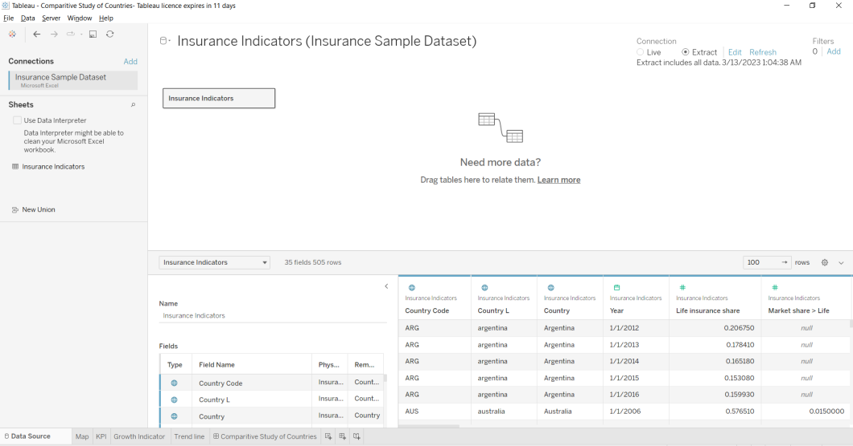

**Question1**

* + Create a geographic map showing the countries' fields. Color the map based on the income column from the secondary dataset
  + Include income group filter in the dashboard.

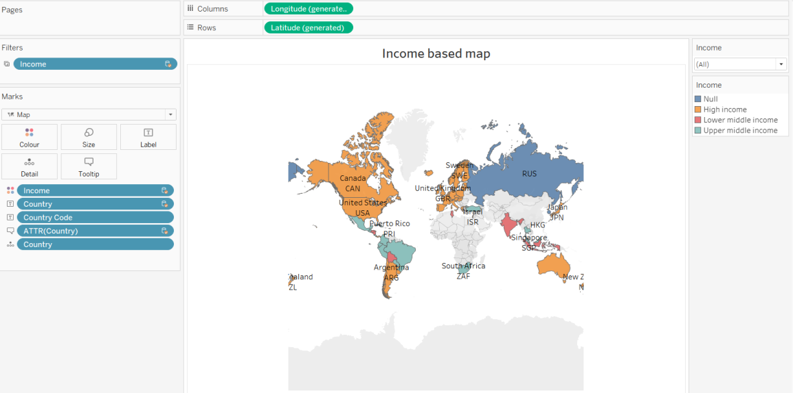

**Question2:**

* + Include a webpage to show data from the world bank web page driven by an URL action from a geography graph. The country names on the map will act as the trigger.

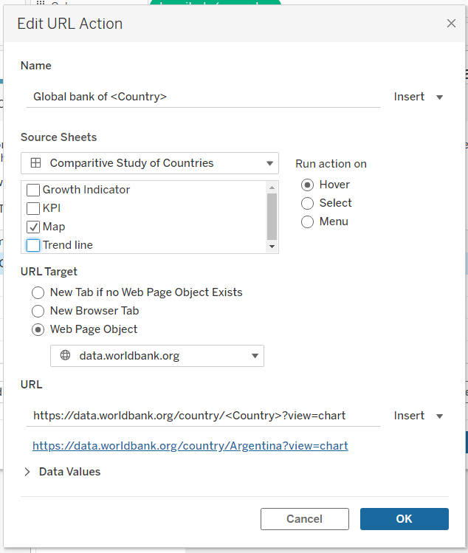

**Question3:**

Create a KPI Table to show the comparison between the selected period and the period prior to the selected one.

The below calculation is to select the category that is only equal to the selected year from the filters.

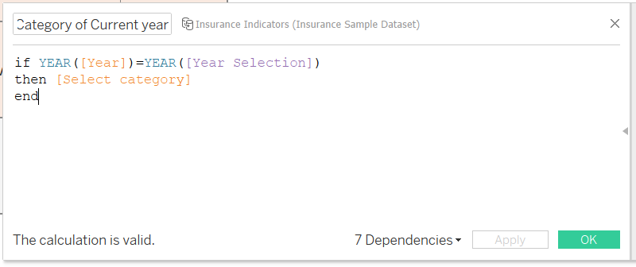

The below calculation is to select the category that is only equal to the selected year -1 (i.e. the last year) from the filters.

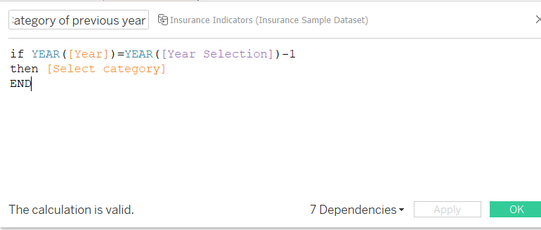

Growth% is the difference of the average of the previous year from the average of the current year.

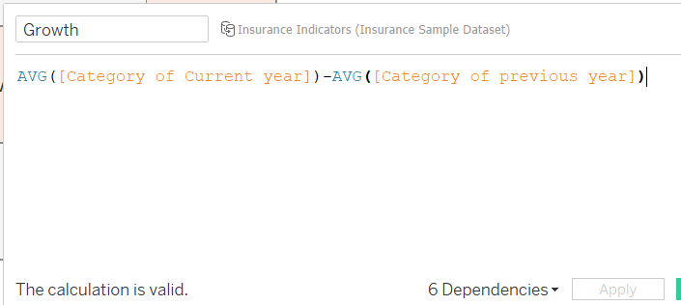

After these 3 calculations, apply them in the sheet to obtain the below result.

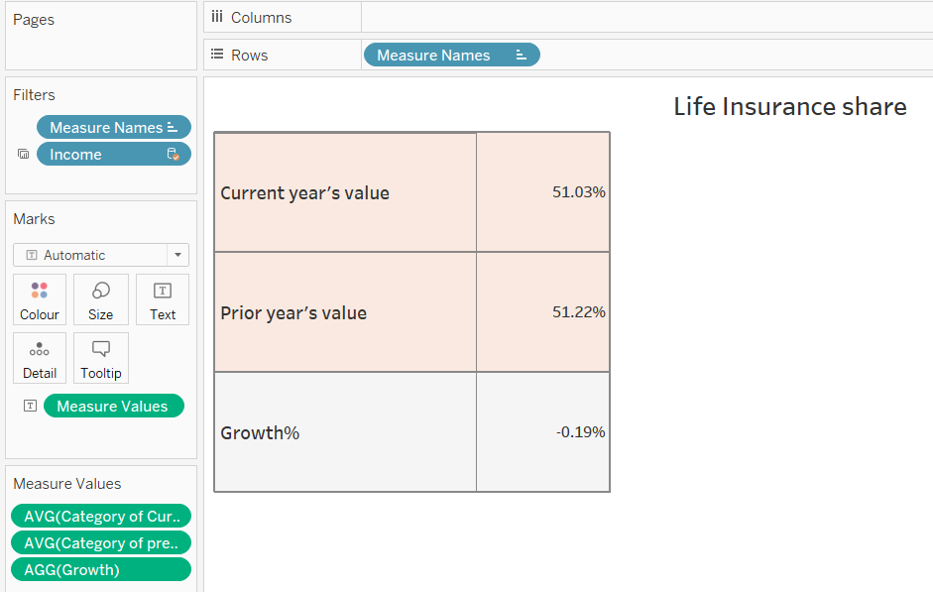

**Question 4**: Create growth indicator shapes based on the Growth%.

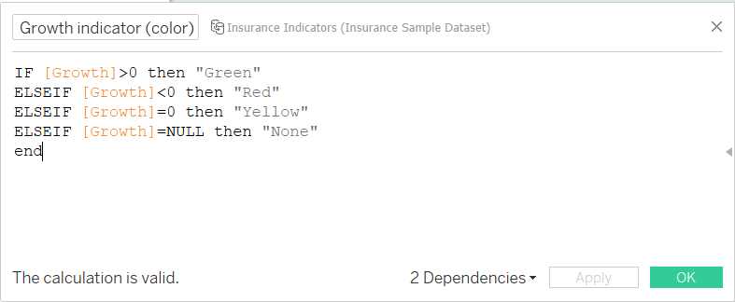

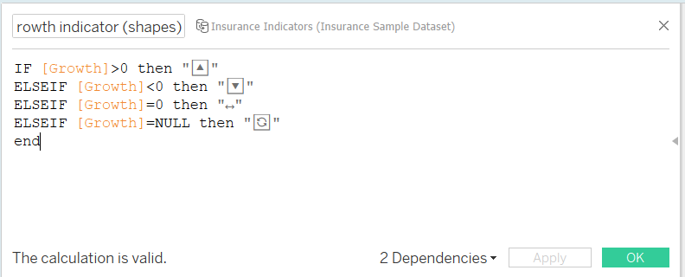

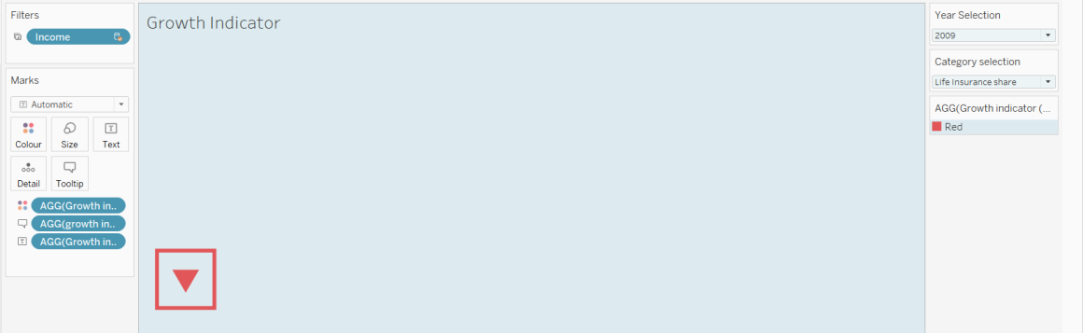

**Question 5**: Create a trend line to show the selected category values.

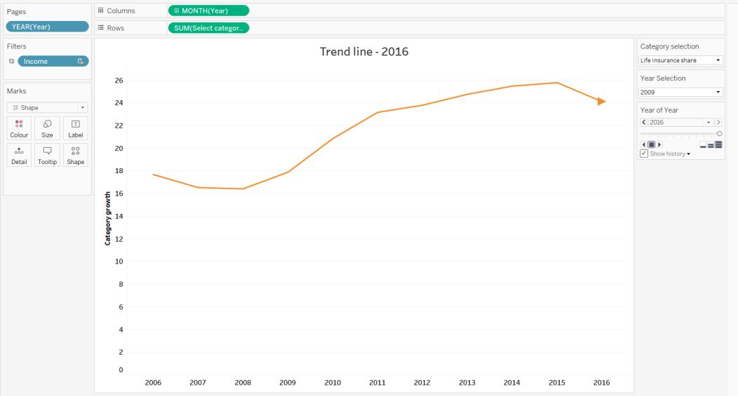

**Question 6:** Create a dashboard filter for income group to be applied for all charts with the filter action enables in the map as well

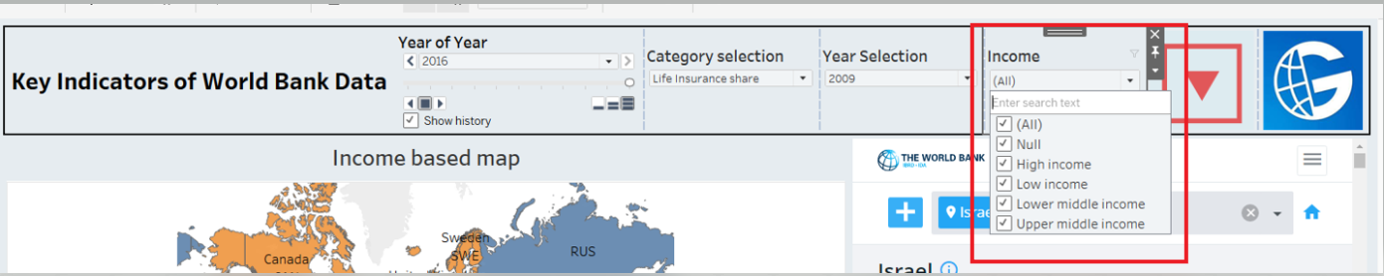

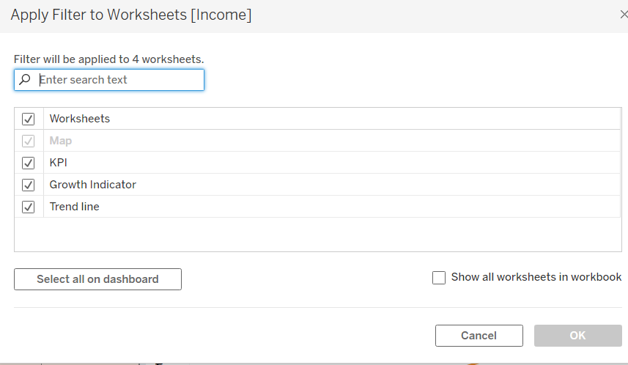

**Question 7:** Formatting should be done appropriately.



